Project Step 16

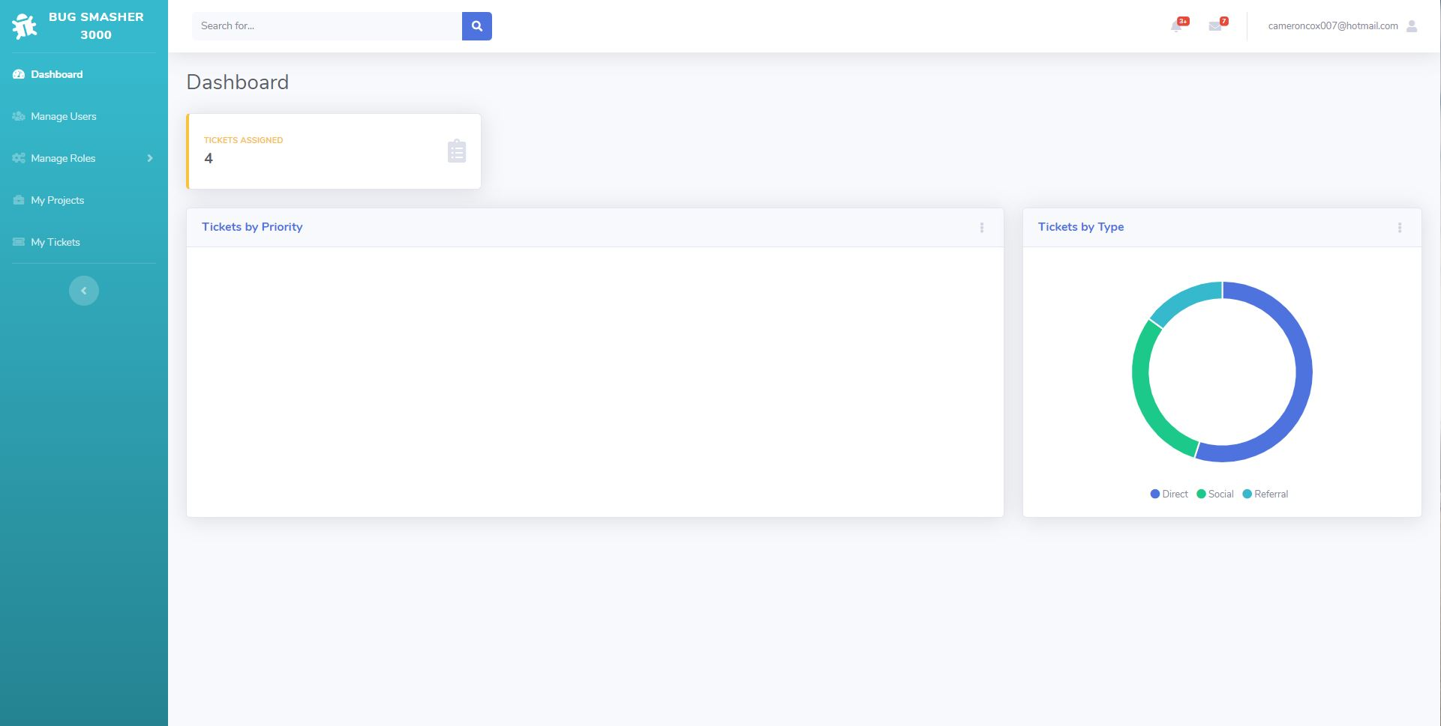

This is the normal desktop view of the home page / dashboard (dashboard is not functional yet).

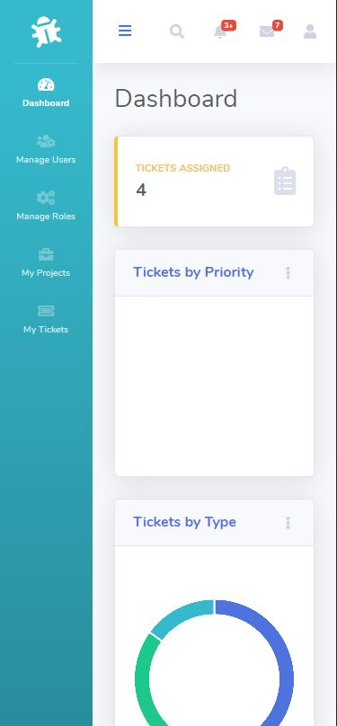

This is the dashboard using the dimensions of an iPhone X. The side navbar automatically collapses giving a lot more room. I might make it collapse even more or even put it below the top nav bar.

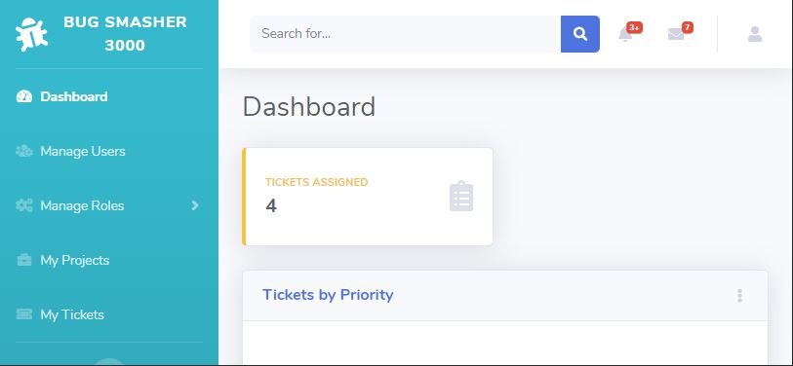

This is what it looks like on an iPhone X rotated sideways. It looks a lot better than the straight up and down view and the side navbar could be collapsed to make even more room. The responsive web design was achieved by using flex in bootstrap and CSS.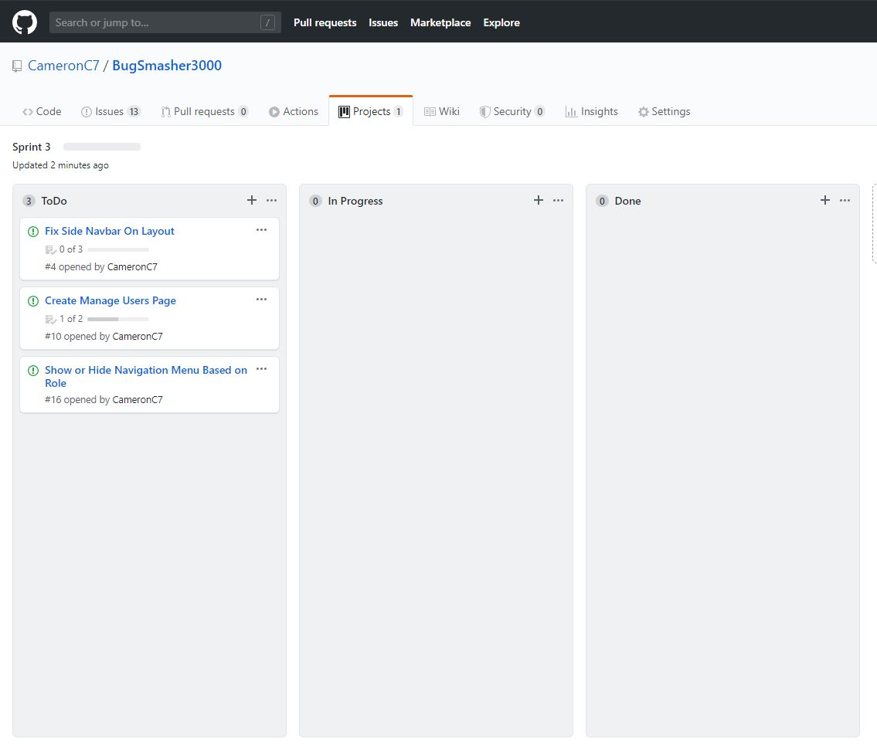

For next week’s sprint I will be working on fixing / finishing the side navbar to add the remaining buttons and link the buttons to their respective views. I will also show or hide certain buttons on the navbar based on assigned roles. And lastly I will start working on being able to assign projects to employees.